3 B Synthesis of Ammonia – The Haber Process
Between 1908 and 1914, Fritz Haber developed and industrialised a catalytic process for the production of ammonia from nitrogen and hydrogen according to the equation:
N_{2 (g)} + 3 H_{2 (g)} 2 NH_{3 (g)}
The Haber process made the production of high nitrogen content fertilisers feasible, which allowed for better crop yields in agriculture. Easy access to reasonably priced fertilisers has reduced starvation and saved lives in many areas across the world. This fact was acknowledged when Haber was awarded the Nobel Prize in Chemistry in 1918, following the end of World War I. However, Haber's involvement in the production of chemical weapons for use by the German army in World War I meant that the award of a Nobel Prize was seen as controversial by many scientists who considered him to be guilty of war crimes.
Ammonia (NH₃) is one of the most commonly produced industrial chemicals. Most of the ammonia produced by industry is used in agriculture as fertiliser. Ammonia is also used in the manufacture of plastics, explosives, textiles, pesticides, dyes and other chemicals. The practical effective synthesis of Ammonia is the result of several typical synthesis considerations

Equilibrium considerations
In Unit 3 we explored Le Chatelier's principle, and learnt how the conditions of a reaction could be changed to shift the equilibrium towards the products:
N_{2 (g)} + 3H_{2 (g)} → 2NH_{3 (g)} ΔH = -92 kJmo1⁻¹

Effect of changing the pressure
In the balanced chemical equation, there is a total of four gaseous molecules on the left-hand (reactant) side of the equilibrium, whereas there are only two gaseous molecules on the right-hand (product) side.
According to Le Chatelier's principle, increasing the pressure will cause the system to partially oppose this increase in pressure by shifting to the side of the equation with less gaseous particles. The side with less gas particles is the RHS – where ammonia is. Therefore, the equilibrium yield of ammonia can be increased by increasing the pressure in the reactor.
Effect of changing the temperature
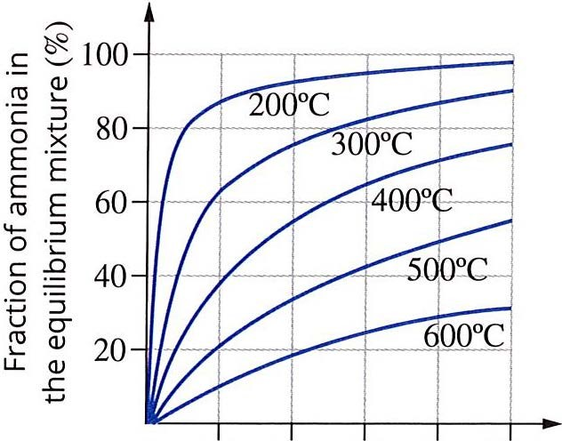
Increasing the temperature is a common method for increasing the rate of a synthesis reaction. However if the reaction exists as an equilibrium, changing the temperature in the reactor will change the equilibrium constant of the reaction. Le Chatelier's principle predicts an increase in the temperature will shift the equilibrium to decrease the temperature. The Haber process is an exothermic equilibrium (ΔH = - 92kJ mol-¹), so if the temperature is increased the equilibrium will shift towards the LHS. Therefore a temperature increase decreases the yield of ammonia.
FIGURE 12.5.2 The percentage of ammonia present when a mixture of nitrogen and hydrogen has reached equilibrium.

200 400 600 800 1000
Pressure (atm)

Effect of a catalyst on the equilibrium
The most common catalyst used in the reaction is finely ground magnetite (Fe₃0₄), which is often fused with other metals oxides. The grinding of the magnetite increases the surface area of the heterogeneous catalyst allowing the gaseous molecules to rapidly absorb and react.
The use of the catalyst increases the reaction rate meaning that the reaction can proceed at a viable rate at a lower temperature than without the catalyst. As explained above, the equilibrium yield of ammonia increases at a lower temperature. So while not directly increasing the amount of ammonia at equilibrium, since the reaction can be performed at a lower temperature the use of the catalyst increases the overall yield of ammonia formed.

Condition of the reaction | Effect on yield | Effect on rate of reaction
Increased temperature
Decreased temperature
Increased Pressure
Decreased pressure
Use of a catalyst

In industry, it is essential to balance the reaction conditions for high equilibrium yield and reaction rate for the best economic outcome. Increasing the pressure of a system, especially on an industrial scale, is a costly and potentially hazardous process. However, in the production of ammonia, a high pressure favours both a high yield and a high reaction rate. In this process, the economic benefits from the increased rate and yield outweigh the cost of maintaining high pressures. A conflict arises in the choice of temperature: a low temperature is desirable for a high equilibrium yield, whereas a high temperature gives higher reaction rates.
The actual conditions used to overcome the conflict between rate and yield in the production of ammonia are:
- high pressures of 100-250 atm
- moderate temperatures of 350-550°C
- a porous iron/iron oxide (Fe₃0₄) catalyst.

Questions.
- Write the chemical reaction for the production of Ammonia, include the state of each reagent.
- Identify the reaction as exothermic or endothermic.
- Which reagent should be removed to increase the yield of Ammonia?
- How does increasing the temperature of the reaction affect the rate and the yield of ammonia?
- Does increasing or decreasing the pressure of this reaction increase the yield of ammonia?
- What effect does a catalyst have on the rate and yield of this reaction?

